**GUI**

graphical user interface



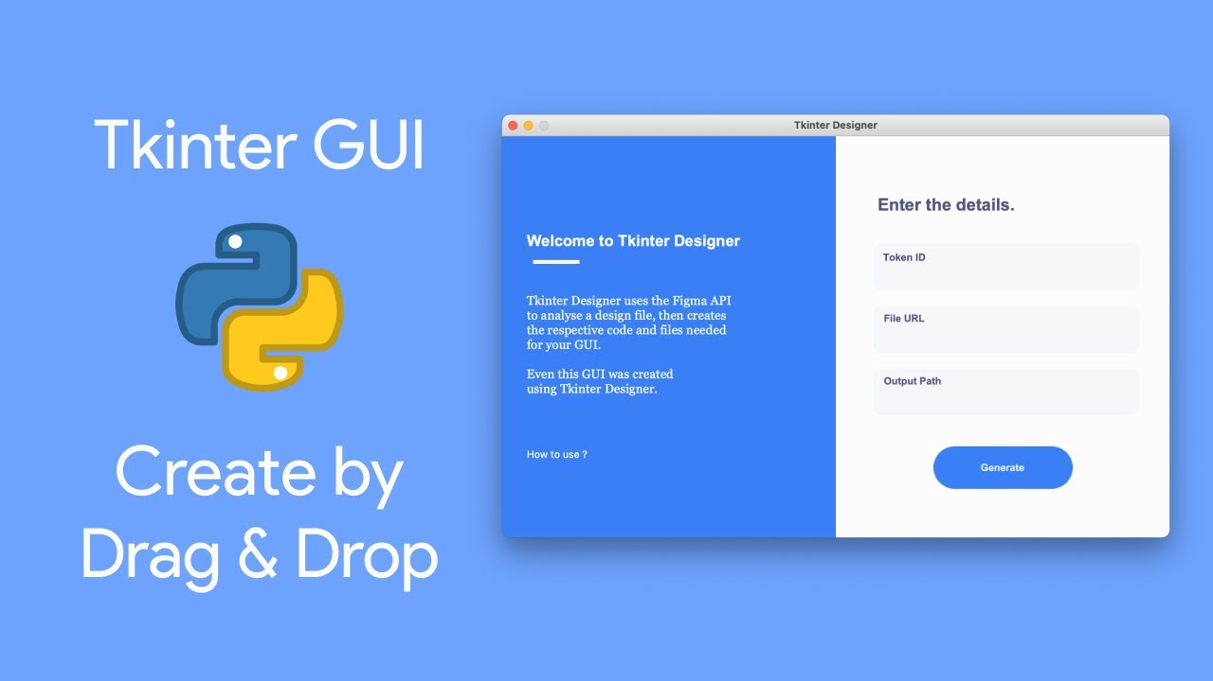

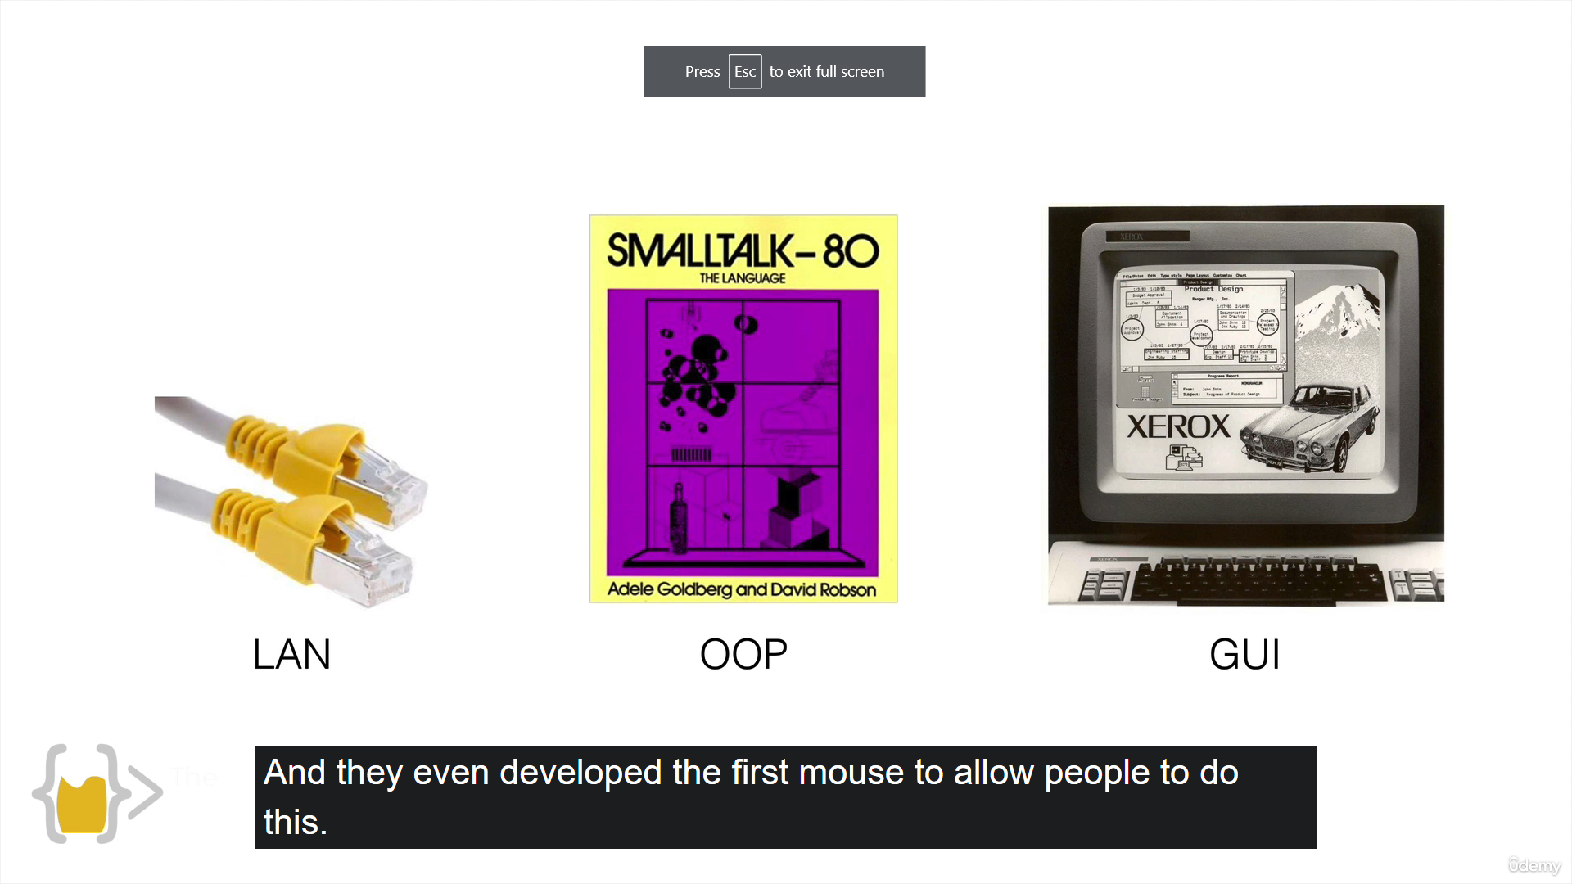



<https://docs.python.org/3/library/tkinter.html#the-packer>

pack()

<http://tcl.tk/man/tcl8.6/TkCmd/pack.htm>

entry()

<http://tcl.tk/man/tcl8.6/TkCmd/entry.htm>

*args

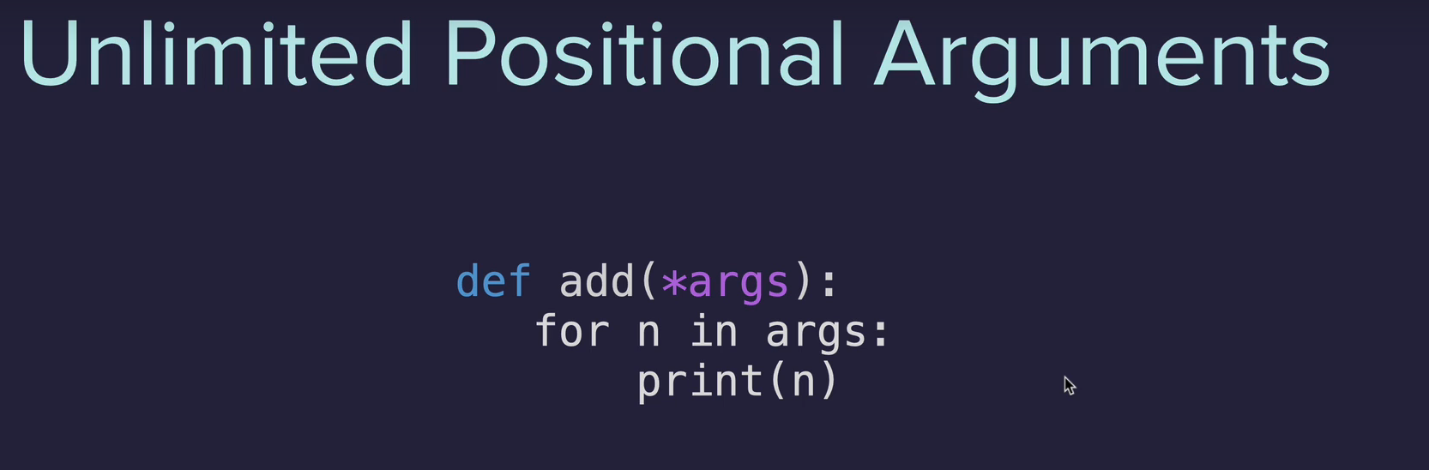

tkinter

